Who remembers our Joan Rosaire and her Wonder Horse Goldy

Although born somewhere on the Welsh/English borders Joan is a Billericay Girl. Her Grandparents circus moved to Wilborough Farm, Cox’s Farm Road, Billericay in the mid-1930s and it remained their winter quarters until the circus closed in 1956. Its first performance of the season was always at Sun Corner Billericay before moving on around the country, including Laindon. Joan still lives in a bungalow in Billericay.
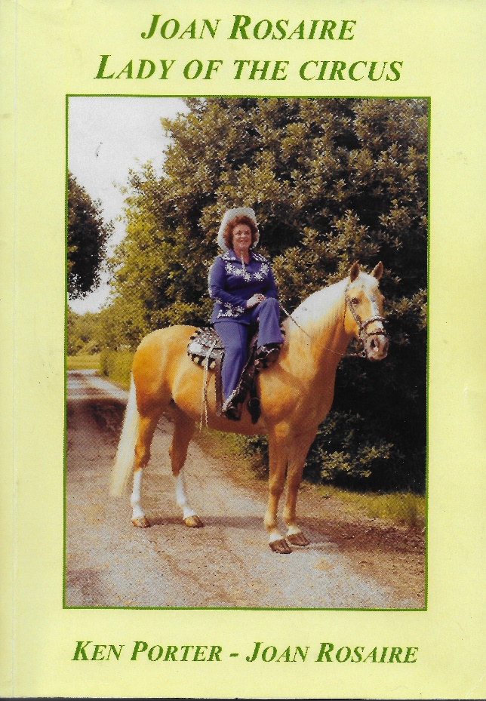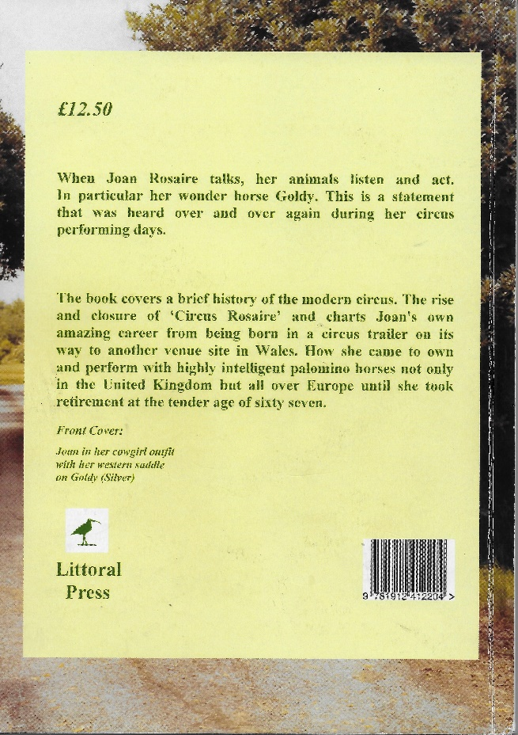
The new book is available at the Basildon Heritage Office, The Green Centre, Wat Tyler Park, Pitsea or on the last Saturday of November at Laindon Library (10 – 12), price £9.00 plus £2.50 if posting is required (RTP £12.50) - It’s also in the Library.
Ken Porter
31/10/2019

